**CMSC 203 Assignment 5**

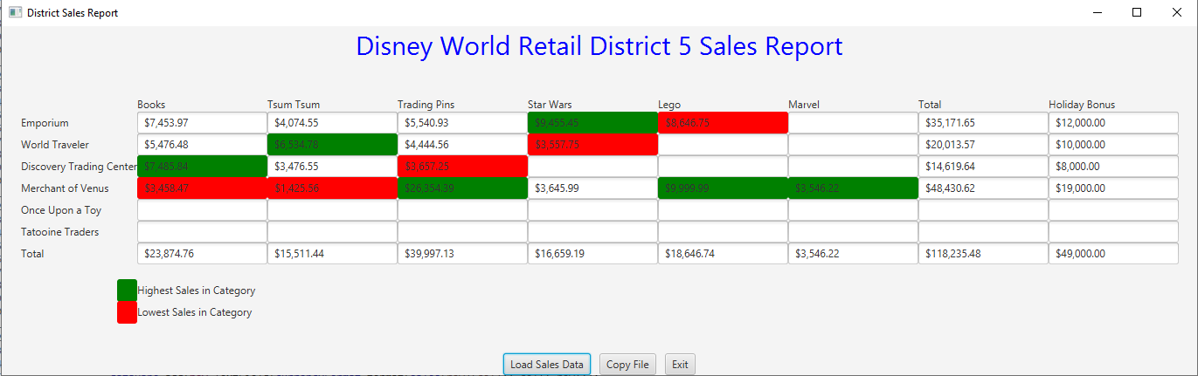**InputFile1**

**InputFile2**

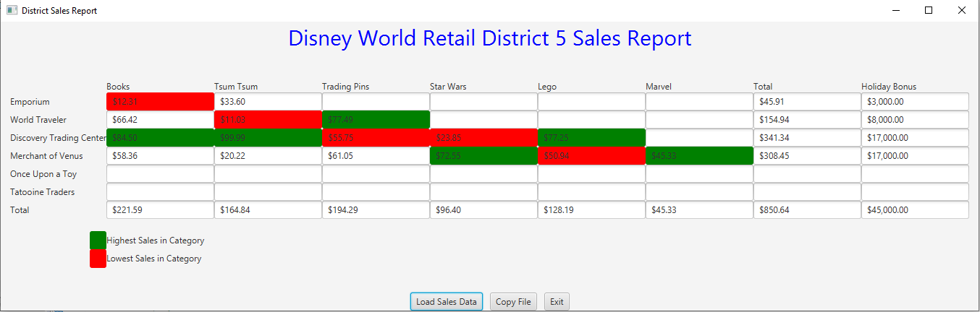

**Test table (InputFile1)**

|  |  |  |  |  |
| --- | --- | --- | --- | --- |
| **Test Case #** | **Input** | **Expected Output** | **Actual Output** | **Remarks** |
| Column 1 | 7453.97, 5476.48, 7485.84, 3458.47 | Highest: 7485.84  Lowest: 3458.47 | Highest: 7485.84  Lowest: 3458.47 | pass |
| Column2 | 4074.55, 6534.78, 3476.55, 1425.56 | Highest: 6534.78  Lowest: 1425.56 | Highest: 6534.78  Lowest: 1425.56 | pass |

**Learning Experience**

Doing this assignment helped me understand how to create classes based on Javadoc, about two dimensional arrays, reading and writing a file and using Junit tests. I also got to know about ragged arrays. This assignment was interesting and fun to work on. Javadoc helped a lot in creating all the required methods. The Junit tests was helpful in finding out errors. I was confused working with the arrays at first but I figured it out after some time.